uni logo 5**Student Placement Induction Checklist**

This checklist is designed to be appropriate whether you are starting your placement online or working from home.

Please check off the items below when they occur and inform your placement organiser of any items not covered. This list is not exhaustive and other topics may be covered, which you may wish to note:

Items with the text ‘(if applicable)’ are likely not to apply to students working from home. In this case leave the section blank and complete these if and when you begin working on business premises.

|  |  |
| --- | --- |
| **Checklist** | **Y/N** |
| I have met with my line manager/supervisor |  |
| I am safe, well and settling into my placement role |  |
| Do you wish to discuss any aspect of your placement experience or wellbeing with a member of University staff? |  |
| Working safely during COVID-19/Coronavirus information and procedures |  |
| Emergency procedures |  |
| Safety policy received or location known |  |
| Accident reporting procedures covered and location of accident book (or equivalent) |  |
| Location of first aid box (if applicable) |  |
| First aid arrangements (including names of first aiders) (if applicable) |  |
| Fire procedures and location of assembly point (if applicable) |  |
| COSHH regulations/procedures (if applicable) |  |
| Manual handling procedures (if applicable) |  |
| Protective clothing arrangements (if applicable) |  |
| Display Screen Equipment Assessment (if applicable) |  |
| Instruction on equipment participant will be using (list equipment) |  |
| **Risk assessments and appropriate training provided (for any risks identified on your online student** [**placement risk assessment**](https://co-tutor.lboro.ac.uk/signon)**). Induction received on ALL hazards indicated on your risk assessment (whether working directly with or in close proximity to) MUST be listed here:** |  |
| Other issues (Please specify): |  |
| **Accommodation** |  |
| I am working from home or have secured suitable accommodation within a reasonable commuting distance (within 90 minutes by car, each way) to/from your place of work? |  |

# Signed:

**Name: Date:**

**Please upload this form to your** [**Co-Tutor**](https://co-tutor.lboro.ac.uk/signon) **record as soon after the start of your placement as possible and no later than 21 days after your start date.**

**If you are on placement and have been instructed to home or remote work**

If you have been instructed to work away from your declared placement location by your placement host, please ensure that you update your placement record on [Co-Tutor](https://co-tutor.lboro.ac.uk/home) with the word ‘HOMEWORKING’ and update your student contact address where you will be based if it is different to that indicated on the system.  If you have any difficulties with this then please contact your [School Placement Team](https://www.lboro.ac.uk/media/wwwlboroacuk/external/content/services/careersandemployabilitycentre/downloads/advice/Placement%20Officers%20Contacts.pdf).

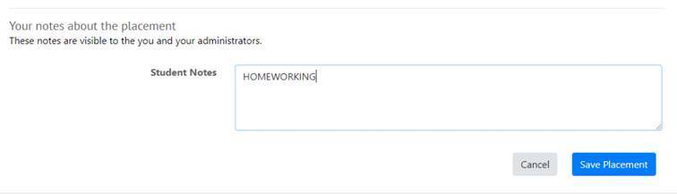

Further information and resources for students working at home or remotely are available at the link [here](https://www.lboro.ac.uk/services/careers/students-and-graduates/placements/out/), under the section ‘remote working resources’.